**VV COLLEGE OF ENGINEERING**

**TISAIYANVILAI**

**Safety Gadget for Child Safety Monitoring and**

**Notification**

**IBM NALAIYATHIRAN**

**Project Development –Delivery of Sprint 4**

**Connecting the Node-Red Service and MIT app With Web UI and Show the child location and notify**

|  |  |
| --- | --- |
| **TITLE** | IOT based child safety gadget for child safety monitoring and notification |
| **DOMAIN NAME** | INTERNET OF THINGS |
| **TEAM ID** | PNT2022TMID49428 |
| **TEAM LEADERNAME** | SUGI.L |
| **TEAM MEMBER NAME** | SANGEETHA.R  SARASWATHI VIDYA  SHOBISHA  SUJI |
| **MENTOR NAME** | BARADWAJ |

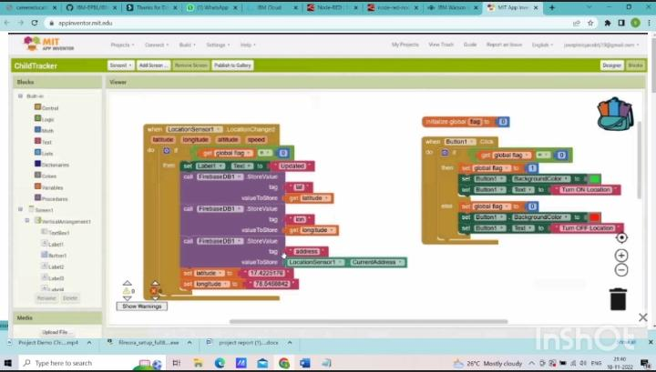

WEB UI:

